Book

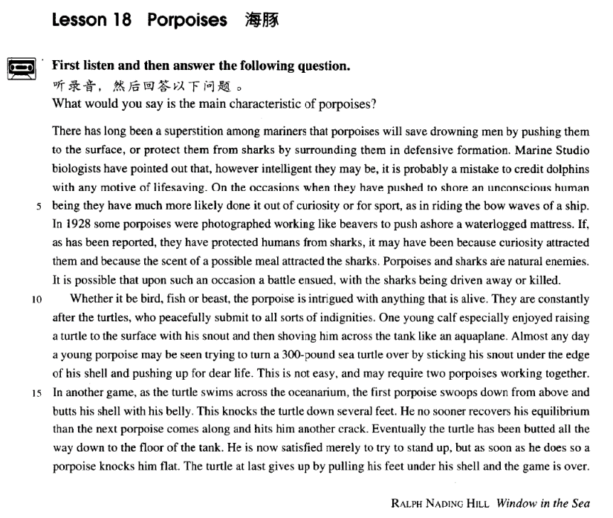

课文

There has long been a superstition among mariners that porpoises will save drowning men by pushing them to the surface,

长期以来，海员中流传着一种迷信的说法，认为海豚会把快要淹死的人托到水面，救人性命；

or protect them from sharks by surrounding them in defensive formation.

或在人们周围列队保护，使他们免遭鲨鱼伤害。

Marine Studio biologists have pointed out that, however intelligent they may be, it is probably a mistake to credit dolphins with any motive of life-saving.

海洋摄影室的生物学家指出，无论海豚多么聪明，认为它们有救人的动机可能是错误的。

On the occasions when they have pushed to shore an unconscious human being they have much more likely done it out of curiosity or for sport,

当它们偶尔把一个失去知觉的人推到岸边时，更大的可能是出于好奇或游戏，

as in riding the bow waves of a ship.

就像它们追逐被船首犁开的浪花一样。

In 1928 some porpoises were photographed working like beavers to push ashore a waterlogged mattress.

1928年，有人拍摄到了海豚像海狸一样把浸透水的床垫推上岸的情景。

If, as has been reported, they have protected humans from sharks,

正如报道中所说，如果海豚保护人不受鲨鱼侵害，

it may have been because curiosity attracted them and because the scent of a possible meal attracted the sharks.

那么它们可能是出于好奇；而鲨鱼可能是闻到了可以美食一顿的香味。

Porpoises and sharks are natural enemies.

海豚和鲨鱼是天然仇敌，

It is possible that upon such an occasion a battle ensued, with the sharks being driven away or killed.

双方可能随之发生搏斗，搏斗结果是海豚赶走或咬死鲨鱼。

Whether it be bird, fish or beast, the porpoise is intrigued with anything that is alive.

海豚对凡是活的东西都感兴趣，不管是鸟、是鱼，还是野兽。

They are constantly after the turtles, who peacefully submit to all sorts of indignities.

它们经常追逐海龟，海龟则温顺地忍受着各种侮辱。

One young calf especially enjoyed raising a turtle to the surface with his snout, and then shoving him across the tank like an aquaplane.

一只小海豚特别喜欢用鼻子把海龟推到水面，然后像滑水板一样把海龟从水池的这一边推到那一边。

Almost any day a young porpoises may be seen trying to turn a 300-pound sea turtle over by sticking his snout under the edge of his shell and pushing up for dear life.

几乎每天都可以看到一只小海豚把鼻子顶入一只300磅重的海龟的硬壳下面，拼命地把它翻过来。

This is not easy, and may require two porpoises working together.

这并非易事，可能需要两只海豚合伙干才行。

In another game, as the turtle swims across the oceanarium, the first porpoise swoops down from above and butts his shell with his belly.

在另一场游戏中，当海龟游过水族馆时，第一只海豚从上方猛扑下去，用腹部撞击龟壳。

This knocks the turtle down several feet.

这一下子把海龟撞下去好几英尺。

He no sooner recovers his equilibrium than the next porpoises comes along and hits him another crack.

海龟刚恢复平衡，第二只海豚又冲过来猛击一下。

Eventually the turtle has been butted all the way down to the floor of the tank.

这只海龟最终被撞到池底。

He is now satisfied merely to try to stand up, but as soon as he does so a porpoise knocks him flat.

此时的海龟，只要能站起来就满足了，但它刚站起来，就被一只海豚击倒。

The turtle at last gives up by pulling his feet under his shell and the game is over.

海龟终于屈服了，将4条腿缩进壳内。游戏到此结束。

词汇讲解

Lesson 18 Porpoises

porpoise ['pɔ:pəs]

n. 鼠海豚

porpoise

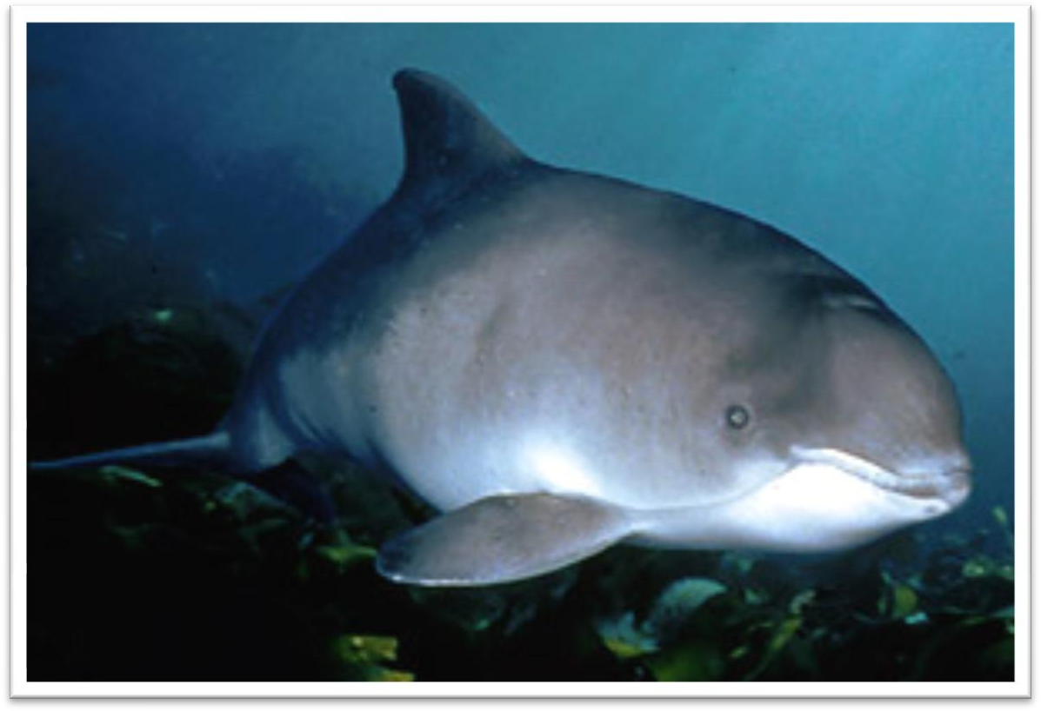

dolphin

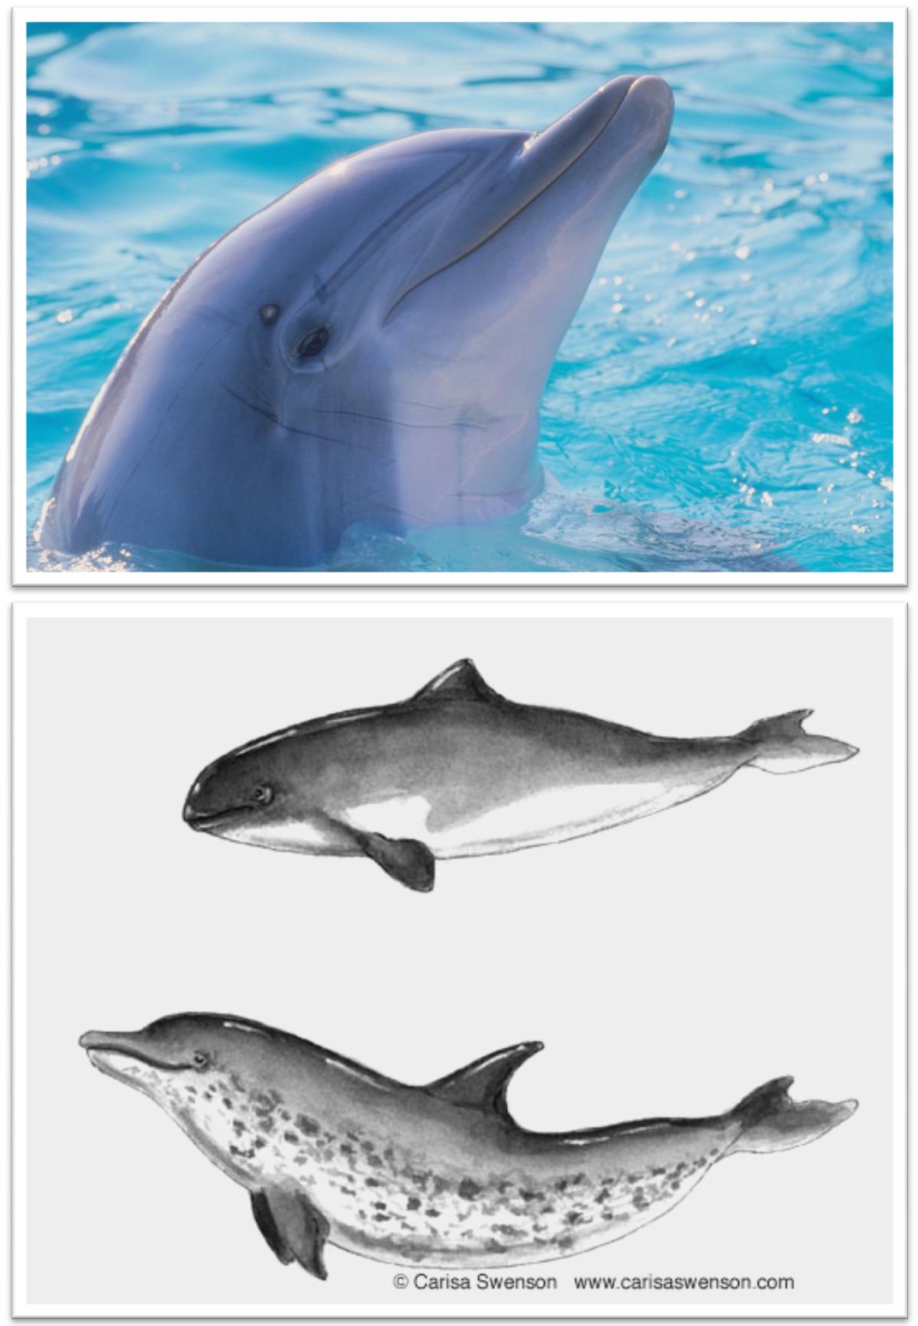

Shark

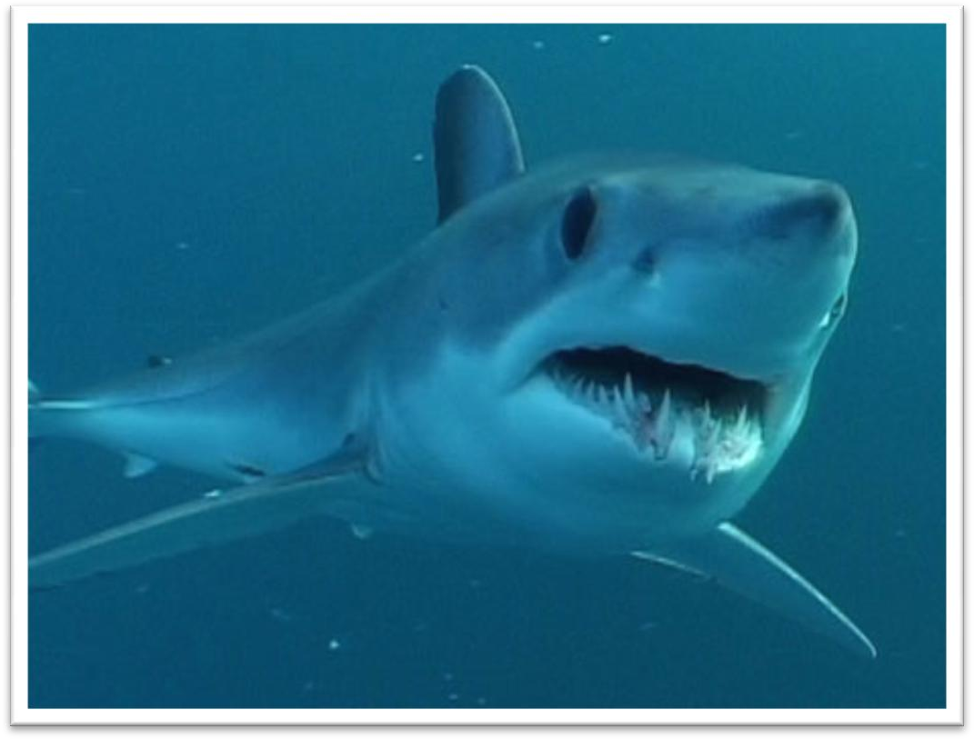

shark-infested waters

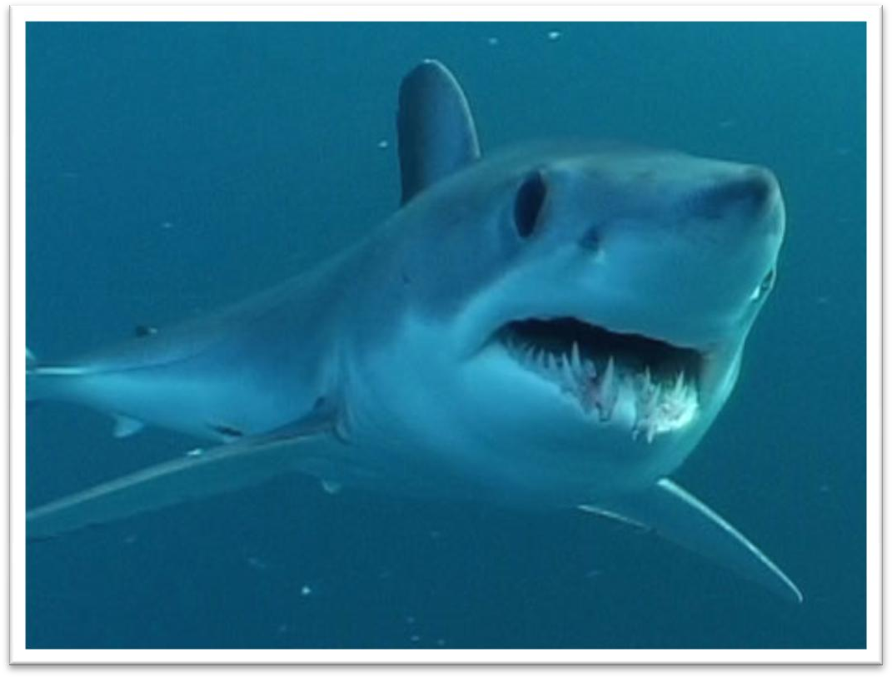

beaver

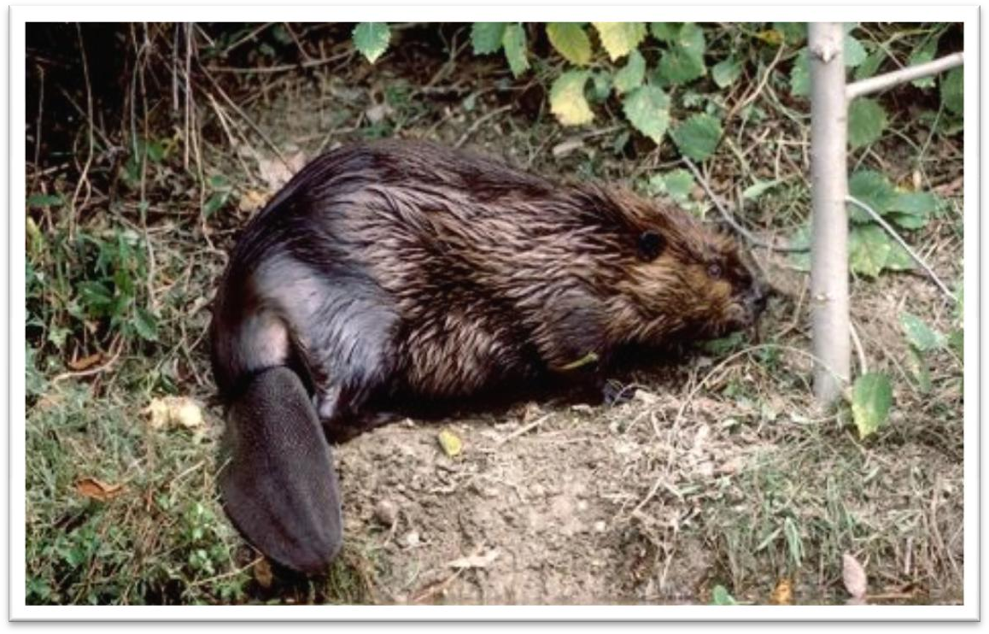

marine

marine life / mammals / products

mariner

sailor / seaman

maritime

maritime museum / law / climate

aquatic

aquatic sports 水上运动aquatic life 水生生物aqua’=water

aqualung 水肺

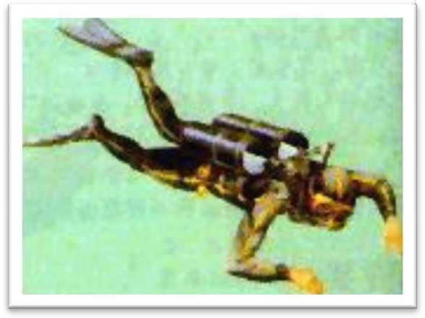

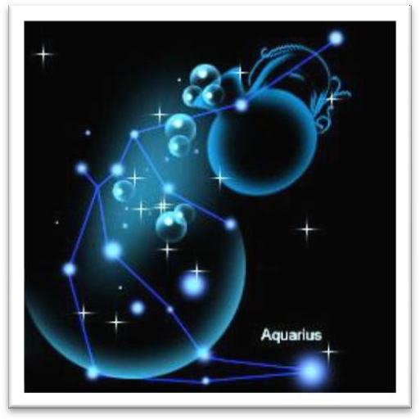Aquarius 水瓶座

aquaplane 滑水板

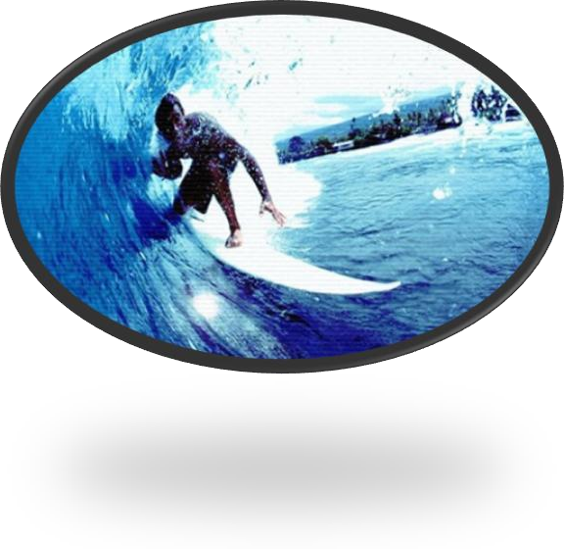

aquarium 水族馆，水族箱

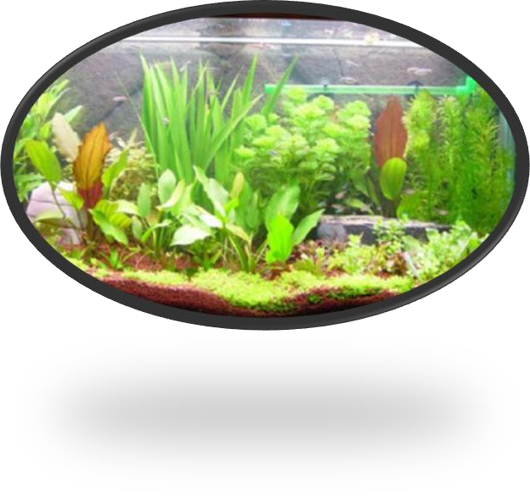

oceanarium 海洋馆

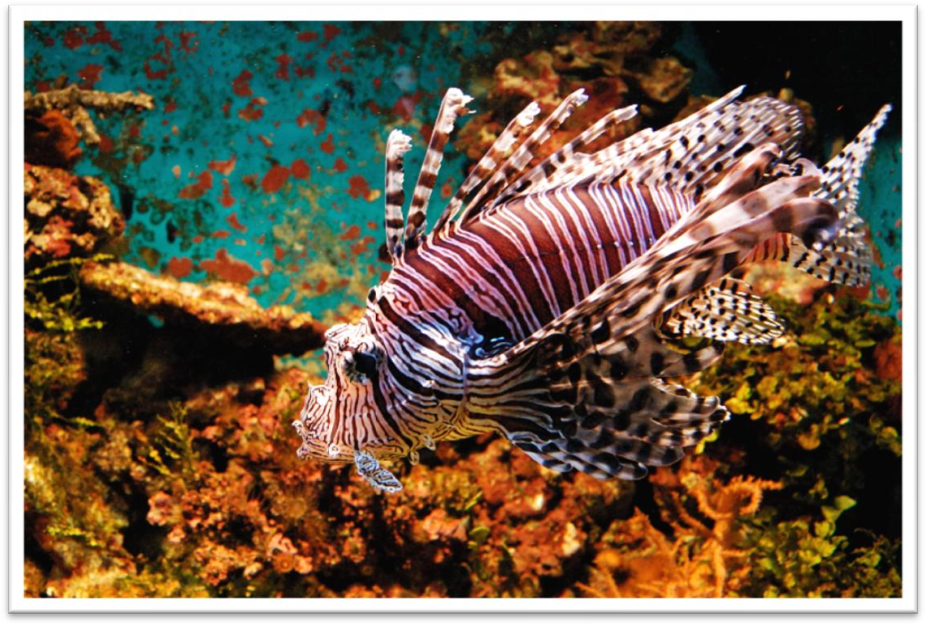

‘ium’ 某个场所

stadium 露天体育场

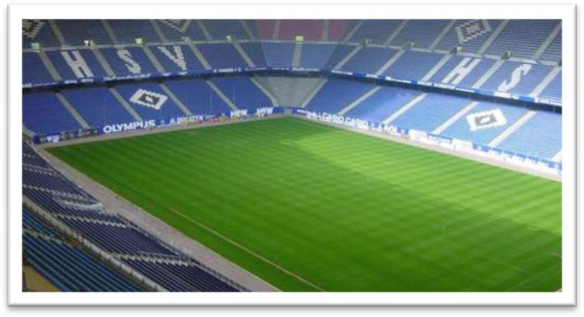

gymnasium 体育馆，健身房

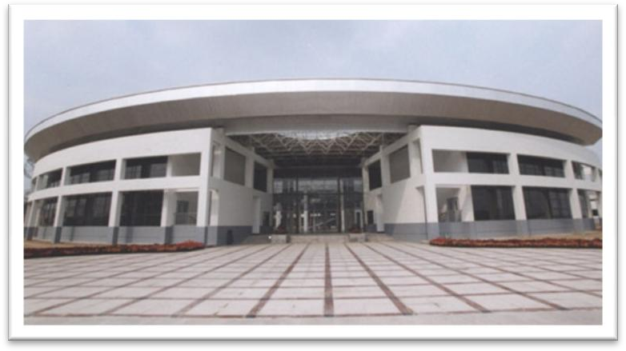

auditorium 礼堂



‘hydr’

hydrant hydrophobia dehydrate

dehydrated vegetables

formation [fɔ:'meɪʃn]

n. 形成，组成；队形，阵形

the formation of a new government

the formation of children's personalities The soldiers advanced in close formation.

The team usually plays in defensive formation / attacking formation / offensive formation / a 4-4-2 formation.

information

reformation economic reformation

deformation deformation of surface malformation congenital malformation transformation

Nixon’s visit led to a transformation of American attitudes toward China. waterlogged ['wɔ:təlɒgd]

adj. 浸满水的

The game was cancelled because of the waterlogged pitch. be soaked / dripping / drenched with …

I’m ~ with sweat. moist

damp humid scent [sent]

n. 香味

scent perfume fragrance the scent of ripe fruit

the perfume of flowers the fragrance of lilacs Scent Of A Woman the Fragrant Hills

aroma the aroma of hot coffee

smell funny smell

smelly smelly feet

odour / odor body odour / odor

odourless / odorless

Carbon monoxide is a colorless, odorless and noxious gas.

ensue [ɪn'sju:]

v. 随之发生，因而发生

I objected what he had just said and a heated argument ensued (from it). come after …

The Napoleonic Wars came after the French Revolution. in the wake of …

In the wake of Thailand’s economic troubles, Malaysia’s currency also sank.

go hand in hand with …

Wealth often goes hand in hand with power. coincide with …

His arrival coincided with my departure. intrigue [ɪn'tri:g]

v. 引起兴趣，激起好奇心

intrigue vt. arouse sb.’s interest or curiosity, usually because sth. is unusual

What you say intrigues me. Tell me more. interest sb.

appeal to sb.

arouse one’s interest / curiosity

intrigue with sb. against sb.

He was intriguing with the barons against the king. intrigue scheme

schemes and intrigues

All the imperialist schemes and intrigues are doomed to failure. shove [ʃʌv]

v. 猛推

Everyone was pushing and shoving, all the way to the gate. butt

The goat butted him in the stomach. gnaw

A rat is gnawing (at) the cable. pounce on …

The tiger pounced on the goat.

He had spotted a tiny bottle at the bottom of my case and he pounced on it with delight.

swoop on …

We saw the hawk swoop on its prey. equilibrium

[7i:kwɪ'lɪbriəm]

n. 平衡

be in equilibrium

For the economy to be in equilibrium, income must equal expenditure. upset the equilibrium

restore / recover equilibrium inner equilibrium

Yoga is said to restore one's inner equilibrium. balance strike a balance upset the balance

We must strike a balance between reckless spending and penny-pinching. These creatures have upset the delicate ecological balance in the lake. balanced

lead a balanced life symmetry

the symmetry of her features symmetric / symmetrical

the symmetric / symmetrical petals harmony

racial harmony domestic harmony We hope we can live together in harmony. harmonious

build a harmonious society

compatible

The couple divorced because they were not compatible. The software isn’t compatible with older operating systems.

There has long been a superstition *among mariners* that porpoises will save drowning men *by pushing them to the surface*, or protect them from sharks *by surrounding them in defensive formation*.

While the quality of legal journalism varies greatly, there is an undue reliance amongst many journalists on interpretations supplied to them by lawyers.

superstition n. 迷信；迷信的观念

superstitious adj. 迷信的

foster superstition

break down / abolish superstition

造句：中国人长久以来迷信看见喜鹊会有好运气。

There has long been a superstition among the Chinese that seeing a magpie will bring you good luck / is a good omen **/** is an auspicious omen.

A bad omen An ill omen

An ominous omen

造句：中国人长久以来迷信听见乌鸦叫是不吉利的。

There has long been a superstition among the Chinese that hearing the

crowing of a crow is an ominous omen.

Marine Studio biologists have pointed out that, *however intelligent they may be*, it is probably a mistake to credit dolphins with any motive of

lifesaving.

Universal Studios

point out 指出，提醒注意

Franz poured scorn on the idea, pointing out that his brother had been killed in action during the war.

At this, the police pointed out ironically that this would hardly be necessary as the men were already under arrest.

in that / but that / except that

After telling several of his friends about the theft, Dimitri found out that his neighbour, Aleko, had suddenly acquired a new lamb.

remark / comment *on sth. / that …*

however intelligent they may be, …

no matter how intelligent they may be, …

although / though / even though / while they may be intelligent, … intelligent *as* they may be, …

Although she is beautiful, I still don’t like her. Beautiful *as* she is, I still don’t like her.

credit sth. to …

credit sb. with sth.

credit dolphins with motive of life saving

I had credited them with more integrity than they showed. I credited you with a little more sense.

motive for / behind sth. the motive for the murder

the motive behind the bombing

Economy is one powerful motive *for* camping, since after the initial outlay upon equipment, or through hiring it, the total expense can be far less than the cost of hotels.

The motive for / behind the bombing is revenge. the motive of revenge

claim – response pattern

claim denial

reasons for denial

On the occasions when they have pushed to shore an unconscious human being they have much more likely done it *out of curiosity* or *for sport*, *as in riding the bow waves of a ship*.

on / upon … occasion on such / rare occasions

Mendoza met Humphries in the ring on a later occasion and he lost for a second time.

It is possible that upon such an occasion a battle ensued, with the sharks being driven away or killed.

instance

In most instances, there will be no need for further treatment. circumstance

Under no circumstances should you approach that man.

… they have pushed an unconscious human being *to shore* …

… they have pushed *to shore* an unconscious human being …

His function is analogous to that of a judge, who must accept the obligation of revealing *in as obvious a manner as possible* the course of

reasoning *which led him to his decision*.

… we have to lower *into the ground* and haul *out of the ground* great

lengths of drill pipes *which are rotated by an engine at the top and are*

*fitted with a cutting bit at the bottom*.

造句：请把我们急需的那个软件从网站上下载下来然后通过 e-mail

发送给我。

Please download *from the website* and send *to me by email* the software *of*

*which we are in urgent need*. out of necessity

out of interest

out of sympathy / pity

out of respect

out of conscience out of desperation

I’m turning to you out of desperation. out of fear

So let us begin anew—remembering on both sides that civility is not a sign of weakness, and sincerity is always subject to proof. Let us never negotiate out of fear, but let us never fear to negotiate.

— John F. Kennedy

Modern alpinists try to climb mountains by a route which will give them good sport, …

for fun / pleasure / amusement

On the occasions when they have pushed to shore an unconscious human being they have much more likely done it out of curiosity or for sport, as (they have done it out of curiosity or for sport) in riding the bow waves of a ship.

Air is to man as water is to fish.

In New York, like in some other cities, environmental pollution is becoming more and more serious.

Air is to man as water is to fish.

In New York, like in some other cities, environmental pollution is becoming more and more serious. X

Air is to man as water is to fish.

In New York, as in some other cities, environmental pollution is becoming more and more serious. √

Air is to man as water is to fish.

In New York, as environmental pollution is becoming more and more

serious in some other cities, environmental pollution is becoming more

and more serious.

It is almost always due to some very special circumstances that traces of land animals survive, as by falling into inaccessible caves, or into an ice crevasse, like the Siberian mammoths, when the whole animal is sometimes preserved, as in a refrigerator.

It is almost always due to some very special circumstances that traces of

land animals survive, as traces of land animals survive by falling into inaccessible caves, or into an ice crevasse, like the Siberian mammoths, when the whole animal is sometimes preserved, as in a refrigerator.

It is almost always due to some very special circumstances that traces of

land animals survive, as traces of land animals survive by falling into inaccessible caves, or into an ice crevasse, like the Siberian mammoths, when the whole animal is sometimes preserved, as the whole animal is

preserved in a refrigerator.

In 1928 some porpoises were photographed *working like beavers to push*

*ashore a waterlogged mattress*. photograph sb. doing sth.

They were photographed playing with the children. an eager beaver

If, as has been reported, they have protected humans from sharks, it may have been *because curiosity attracted them* and *because the scent of a possible meal attracted the sharks*.

as 引导的非限定性定语从句与which 引导的非限定性定语从句的区别。

1、as 作为关系代词指代整个主句，而 which 作为关系代词指代整个主句或先行词均可。

2、as 引导的非限定性定语从句位于主句前、中、后均可，而 which

引导的非限定性定语从句不能位于主句之前。

As a poet points out, life is but a dream. Children, as is always the case, love their mother. She became angry, as many could see.

3、as 引导的非限定性定语从句含有“众所周知”的意思，常译为“正

如……”，而which 引导的非限定性定语从句则未必有这个意思。

The sun heats the earth, which makes it possible for plants to grow.

4、在“as + be 动词 + done”结构中可省略 be 动词 ，而在 “which + be

动词 + done”结构中可省略“which + be 动词 ”，而不能只省略 be 动

词。

As (is) reported, a foreign delegation will visit the city. a puma (which was) at large

If, as reported, they have protected humans from sharks, …

As Napoleon once pointed it out, attack is the best method of defense. As Napoleon once pointed it out, attack is the best method of defense. X As Napoleon once pointed out, attack is the best method of defense. √

Cave exploration, or pot-holing, as *it* has come to be known, is a relatively new sport.

The problem, as I see *it*, is no big deal.

The author was brought up in a small village, as *it* is recounted in some of his stories.

as / so / such / the same … as …

I need the tool which you are using.

I need the same tool as you are using. I need such a tool as you are using.

I need as useful a tool as you are using.

Such inns as there were were generally dirty and flea-ridden. It is because … √

The reason is because … X The reason is that … √

… the reason may have been that curiosity attracted them …

This rabbit had no natural enemies in the Antipodes, …

It is possible that upon such an occasion a battle ensued, with the sharks

being driven away or killed.

Whether it be bird, fish or beast, the porpoise is intrigued with anything that is alive.

Whether it is bird, fish or beast, ……

After all, all living creatures live by feeding on something, whether it be plant or animal, dead or alive, and it is only by chance that such a fate is avoided.

Whether she be right or wrong, she will have my unswerving support. Though he be the President himself, he shall listen to us.

Be it bird, fish or beast, ……

Home is home, be it ever so homely.

Home is home, though it be ever so homely.

Once the educators, be they administrators or teachers, are under the control of students, even a democratic situation would be like holding royalty accountable to the mob.

Once the educators, whether they be administrators or teachers, are under the control of students, even a democratic situation would be like holding royalty accountable to the mob.

They are constantly after the turtles, who peacefully submit to all sorts of indignities.

be after … 追逐；追捕；想抓住或得到…… The police are after the fugitive.

He’s after my job.

I’m sure she’s after my husband.

submit to … 服从……；屈服于……；甘心忍受…… All countries in the EU must submit to its laws.

I’m not prepared to submit to this painful course of treatment.

First, you must give Helen back to my brother. Second, Troy must submit to my command to fight for me whenever I call.

bow to …

The government refused to bow to terrorists. yield to …

succumb to … be subject to …

All employees are subject to the regulations of the company.

So let us begin anew—remembering on both sides that civility is not a sign of weakness, and sincerity is always subject to proof. Let us never negotiate out of fear, but let us never fear to negotiate.

— John F. Kennedy

calf foal piglet

lamb kid fawn

cub kitten puppy chicken duckling gosling

larva infant

Almost any day a young porpoise may be seen trying to turn a 300-pound sea turtle over *by sticking his snout under the edge of his shell and pushing up for dear life*.

Stick’em up! Stick your tongue.

for dear life 拼命地……

for life 终生，一辈子

The accident left her scarred for life.

No sooner *does* he recover his equilibrium than the next porpoise comes along and hits him another crack.

be satisfied with / to do … be content with / to do …

…, but no sooner *does* he do so than a porpoise knocks him flat.